BA STAY ABROAD AGREEMENT SHEET
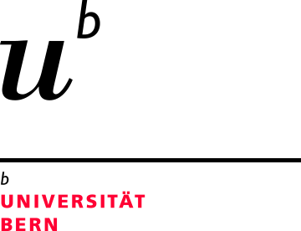
Department of English, University of Bern

To be filled in by student and completed and signed by International Coordinator

Student’s name: _______________________________
Matriculation number:_______________________________ □ Major □ Minor

PLANNING YOUR STAY ABROAD:
A) Duration, Nature, and ETCS Accrediation of Stay Abroad

Duration of stay | Projected activity | ECTS
6 months (23+ weeks) |  | 10
5 months (19-22 weeks) |  | 8
4 months (15-18 weeks) |  | 6
3 months (11-14 weeks) |  | 5
2 months (7-10 weeks) |  | 4
1 month (4-6 weeks) |  | 3

B) ECTS points to be credited for courses taken at host university (max. 30 ECTS)

Course title | Host Uni  Sem/Lect | Graded / Ungraded | ECTS | Unibe  WB/OC/FZ
WB = Wahlbereich / Electives Bachelor (graded);
WL = Wahlleistung / Electives in the Department (ungraded);
FZ = Freiwillige Zusatzleistungen / Additional optional attainments (graded or ungraded)

B1) SEMP learning agreement (if applicable) separate form

C) Completing your Stay Abroad
Once you have completed your stay abroad requirement (whether done in one go or divided into several parts), please submit a complete dossier, in one email, to the International Coordinator so it can be processed and your points entered into KSL.

□ The original Stay Abroad Agreement Sheet
□ Proof of the duration of the stay (e.g. flight tickets)
□ A 750 words report or a podast to be uploaded on the Stay Abroad Ilias site
□ Filled-in Submission Sheet
And either:
□ A university transcript; or other certificate; or
□ A letter from the student’s employer/manager confirming
a) duration (exact dates) of employment and
b) percentage worked = min 40% (= 16 hours)

Please note: The IC will not keep copies of your stay abroad documents on your behalf, please make sure to keep any copies of any documents signed by or submitted to the IC.

Date:

Signature student:

Signature IC:

Courses taken abroad can be accredited as: - Wahlleistungen (OC): courses must be related to English literature or linguistics, ungraded. - Wahlbereich (WB): can be any discipline, graded. - Freiwillige Zusatzleistungen (FZ), if the credits are not required to complete the BA.

